** **

**Phase2 Project Final SDS**

**Course Name : Software Engineering 1**

**Course Code : CS251**

**Project Name : Automated Parking Garage System**

**Leader Name : Nourhan Abdo Mohamed**

**Team Information**

|  |  |  |  |
| --- | --- | --- | --- |
| **Group** | **Email** | **ID** | **Name** |
| **G4** | [**medoali376@gmail.com**](mailto:medoali376@gmail.com) | **20120329** | **Mohamed Ali Ahmed** |
| **G4** | **nourhanabdo6@gmail.com** | **20120437** | **Nourhan Abdo Mohamed** |
| **G3** | **mahetab.dagher@gmail.com** | **20120288** | **Mahetab Saadony Kamel** |

1 - Document Purpose and Audience :

**This document contains class diagram and sequences diagrams and GUI for customers and systems and system decomposition .**

**Audience :** **designers ,** **manager , developers , programmers , and workers.**

**1 – System Decomposition**

**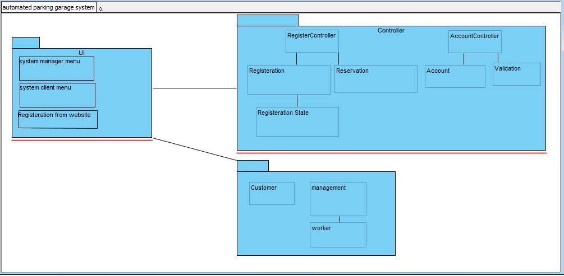  
  
  
2 - Class Diagram :**

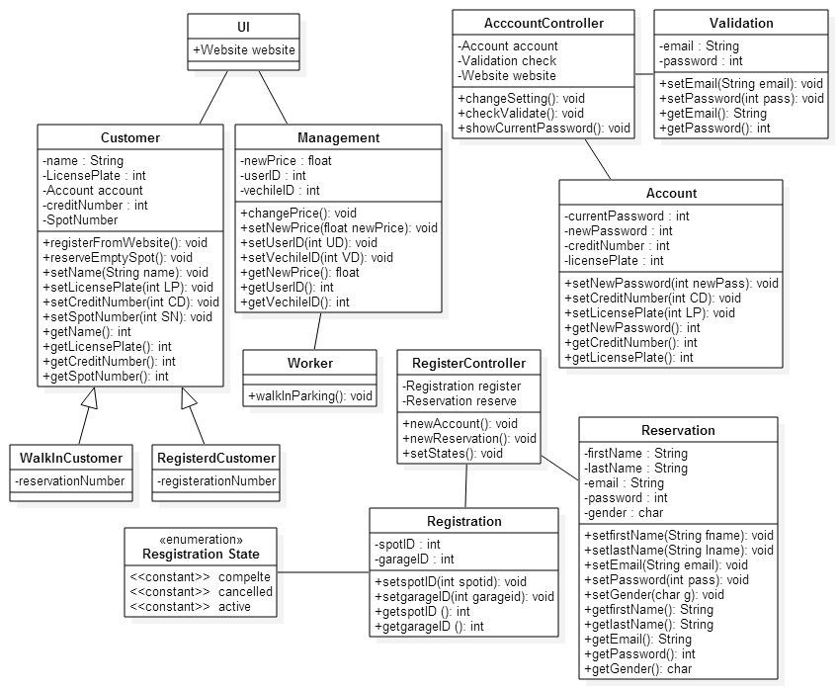

**3 – Classes Sequence :**

**3.1 – Walk In Sequence Diagram**

**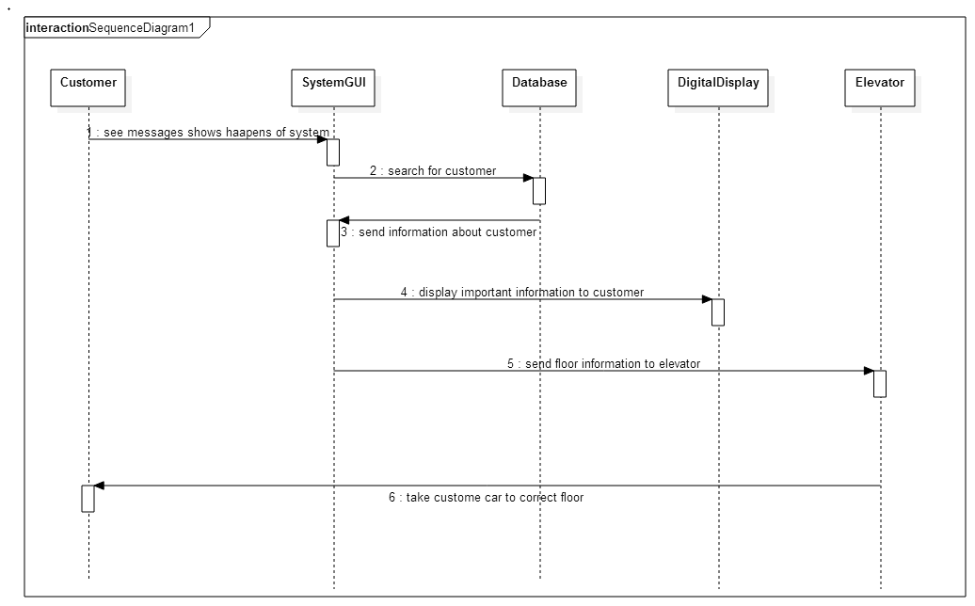  
  
  
3.2 - Reservation Sequence Diagram  
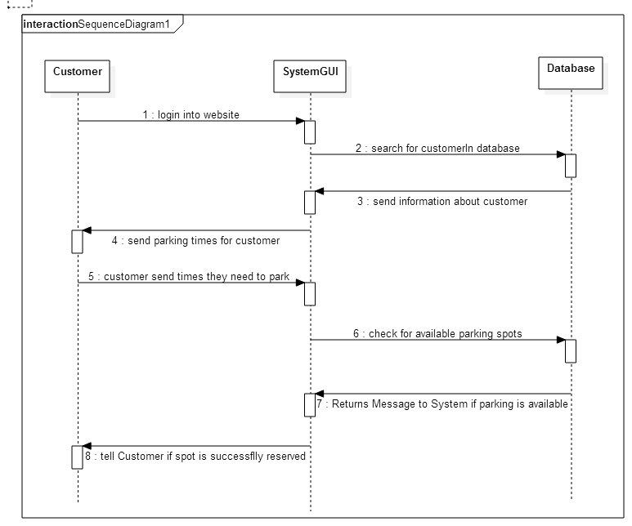**

**3.3 – Unregistered Customer sequence diagram**

**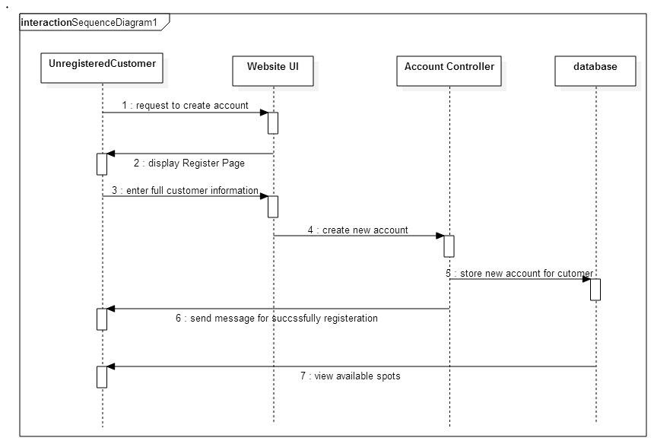  
  
3.4 – Manager Sequence Diagram**

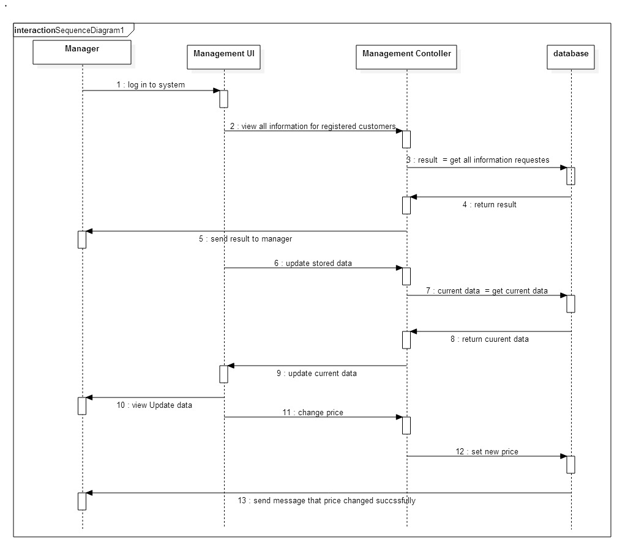

**3.5 – Edit Reservation sequence diagram**

**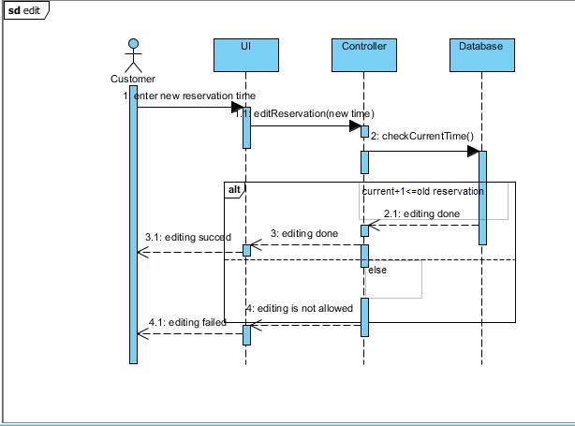  
  
4.6 – Cancel Reservation sequence diagram**

**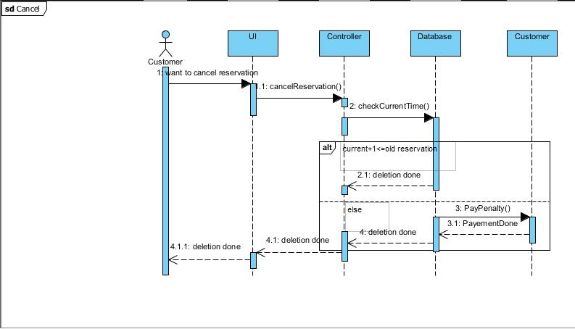  
  
  
4.7 – Read License Plate Number sequence diagram**

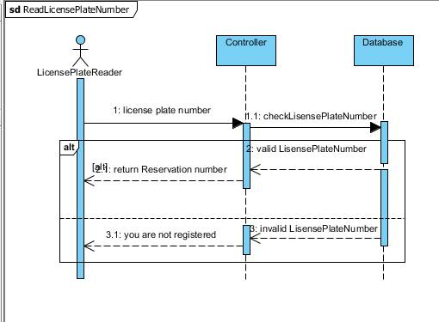

**4 – ERD**

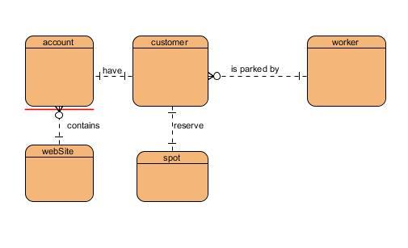

**5 - Classes Interface**

